|  |  |
| --- | --- |
| COMP639: Planning Report  Lincoln University Leave Management Application |  |
|  |  |
| APRIL-JUNE 2023  Group 3:  Authored by: H Dai, S Duan, M Sang, M Tian and B Willis |  |

Table of Contents

Lincoln University Leave Management Application 3

1. Group Members 3

2. Project Overview 3

3. User Stories 4

4. Proposed Database Design 15

5. Proposed Time Allocation 16

6. Sprint 1 Planning 17

# Lincoln University Leave Management Application

|  |  |  |  |  |  |  |  |  |  |  |  |  |  |  |  |  |  |  |
| --- | --- | --- | --- | --- | --- | --- | --- | --- | --- | --- | --- | --- | --- | --- | --- | --- | --- | --- |
| Group Members  |  |  |  | | --- | --- | --- | | Name | Student ID | Skills | | Hido Dai | 1155066 | MySQL, debug | | Sherlyn Duan | 1155117 | Prototype, design, front-end | | Miao Sang | 1114842 | Prototype and design | | Mia Tian | 1154238 | Design and coding | | Belinda Willis | 1152570 | Project Management | |
| Project Overview The proposed project involves designing and implementing a new Leave Management System for Lincoln University (LU) to efficiently manage the leave records of its employees. The current system of leave request and approval via email is cumbersome, time-consuming and prone to errors. Therefore, the new system will be developed to streamline the leave management process for the university.  The project will be implemented in several stages, such as requirements gathering, system GUI and database design, development using python flask and also testing to ensure it meets all requirements and is free of defects.  It is believed that the new Leave Management System will improve efficiency, reduce errors, and enhance transparency in the leave management process at Lincoln University. |

### User Stories

|  |  |  |  |  |
| --- | --- | --- | --- | --- |
| **Sprint/Priority** | **Role (As a)** | **I want to** | **Purpose (So that)** | **Criteria** |
| **1** | **employee** | **I want to log in to the leave management system with my credentials** | **so that I can apply for leave.** | **1, The login page should be secure and encrypted, such as using bcrypt to secure password. (PO just wants hidden) 2, The system should authenticate email and password 3, The system should display an error message if my email or password is incorrect. 4, After log in, users should see the dashboard - just one for everyone (other roles will see extra buttons)** |
| **5** | **employee** | **I want to receive a notification when my leave request is approved or rejected** | **so that I can plan accordingly.** | **1, The system should send a notification through email or mobile number when my leave request is approved or rejected. 2, The notification should include if my leave request is approved or rejected and the reason if it is rejected.** |
| **1** | **employee** | **I want to view my own details such as Title (e.g. Doctor/Professor/Mr/Mrs), First Name, Family Name, Joined Date, Position Title, Position Start Date, Department, reports to , approval manager** | **so that I can ensure that my records are accurate.** | **1, Users can click on Account to view details 2, The system will display Name (including title), username, joined date, position title, position start date, department, reports to name, approval manager name.** |
| **3** | **employee** | **I want to make a leave request by specifying the type of leave, the start and end dates of my leave, and the reason for my leave...(I want to be able to request a start date up to 1 month prior and an end date up to 1 year in advance for my leave - calendar setting)** | **so that my manager can review and approve it.** | **1, The system should allow users to select the type of leave, including Annual, Bereavement, Parental, Sick Family, Sick Leave, Special Leave without Pay and Special leave with Pay. 2, The system should allow users to select a start date and an end date from a calender 3, The system should allow users to provide additional info, such as reasons for leave request. 4, A confirm page should show the details of the request including a calculation of the leave units requested in both hours and days. if a leave request date range includes public holidays or weekends, these days are not counted in the calculation.** |
| **3** | **employee** | **I want to be able to see which dates I have already requested or have been approved for leave on a calendar, and have those dates shaded a different color and made unclickable.** | **so that I can easily distinguish them from the available dates and avoid accidentally requesting leave on those dates.** | **1, The employee should be able to view a calendar that displays all available leave dates. 2, The dates that the employee has already requested or have been approved for leave should be shaded a different color from the available dates and not clickable.** |
| **3** | **employee** | **I want to be able to see all my leave requests and their status (approved, unapproved, or rejected)** | **so that I can plan my work schedule accordingly.** | **1, The system should display all leave requests, if possible, allow users to sort and filter leave requests by different criteria such as date or status.. 2, For each request, the system should display the type of leave, start and end dates, reason for leave, approval manager and status.** |
| **3** | **employee** | **I want to be able to edit/delete all my leave unapproved requests** | **so that I can make adjustments to my work schedule if necessary..** | **1, Employees should be able to click on unapproved leave requests and then update or delete a request. 2, System needs to validate updated request before users can submit. 3, Employees can not delete or edit, but only view approved leave. 4, The system should update leave balance accordingly.** |
| **2** | **employee** | **I want to be able to see my current leave balance. (as at close of last pay - balance is stored in the database and is updated fortnightly )..** | **so that I can plan my leave requests accordingly.** | **1, Leave balance needs to be stored in hours but displayed in days. 2, For Annual Leave (at close of last pay), it should include annual leave balance (stored in the database) , Leave approved not paid (calculated) , Leave applied not yet approved. (calculated) 3, For Sick Leave , (at close of last pay), it should include sick leave balance (stored in the database) , Leave approved not paid, (calculated) Leave applied not yet approved. (calculated)** |
| **2** | **employee** | **I want to be able to see my projected leave balance for a particular date** | **so that I can plan my leave requests accordingly.** | **1, The system should allow employees to select a future date for which they want to view their projected leave balance.2, The system should calculate the projected leave balance based on the employee's leave accrual rate and any approved, pending, or rejected leave requests. 3, The system should display the projected leave balance(hours and days) for the specified date. 4, The system should inform the employee if the selected date is in the past or if it's invalid.** |
| **5** | **employee (everyone)** | **I want to be able to change my password** | **so that I can ensure the security of my account.** | **1, The system should have a "Change Password" option in the user's account settings. 2, The system should require the employee to enter and confirm their new password. 3, The system should display a success message upon successful password change.** |
| **3** | **Approval Manager/ and Admin** | **I want to be able to view leave requests** | **so that I can process them accordingly.** | **1, The system should display a clickable list of new leave requests on the approval manager's dashboard upon login. 2, The system should provide a "To Do" or "Action Items" section on the dashboard where the approval manager can view and action leave requests with relevant details. 3, The system should allow the approval manager to view the full details of a leave request.** |
| **5** | **Approval Manager** | **I want to be alerted when there are new leave requests (notifications lowest priority)** | **so that I can review and take action in a timely manner.** | **1, The system should send an email notification to the approval manager when a new leave request is submitted.2, The system should provide a visual indicator (e.g., badge) on the leave request page to show the number of new leave requests.** |
| **3** | **Approval Manager** | **I want to be able to manage (edit, reject, delete, approve) leave requests (manage leave requests could be one US)** | **so that I can manage my team's leaves effectively.** | **1, The manager should be able to select a leave request to delete.2, The system should display the current details of the selected leave request 3, The manager should be able to delete the leave request** |
| **3** | **Approval Manager** | **I want to be able to search for a particular leave request (search by employee or date or something else - restrict based on role)** | **so that I can quickly locate and review it.** | **1, The system should provide a search bar on the leave request page for approval managers. 2, The system should allow approval managers to search for leave requests by different criteria (e.g., employee name, leave dates, leave type, status).3, The system should display search results with relevant details and allow the approval manager to take actions as needed.** |
| **3** | **Approval Manager** | **I want to be able to see a list of all employees that I have delegated authority to approve leave for and view their balances, and requests (admin can see anything or anyone but cant approve their own leave)** | **so that I can make decisions.** | **1, The system should display a list of employees under the approval manager's authority. 2, The system should allow the approval manager to view employee details, balances (in hours and days), and requests for a selected employee. 3, The system should provide the Projected Balance Calculator for the employee.** |
| **4** | **Approval Manager and Admin** | **I want to have a Leave Exception Report that shows a list of employees with an annual leave balance equal to or greater than 30 days** | **so that I can identify potential issues and manage leave balances effectively.** | **1, The system should generate a Leave Exception Report based on the specified criteria. 2, The report should include first name, last name, position, department, leave balance (hours), and leave balance (days), sorted by highest leave balance. 3, The report should only show employees that the approval manager has delegated authority to approve leave for.** |
| **4** | **Approval Manager/ and Admin** | **I want to have an Annual Leave Liability Report that shows a list of all employees and their leave balances under my authority** | **so that I can have a clear overview of the leave situation in my team.** | **1, The system should generate an Annual Leave Liability Report for employees under the approval manager's authority. 2, The report should include first name, last name, position, department, leave balance (hours), and leave balance (days), sorted by first name and last name.3, The report should only show employees that the approval manager has delegated authority to approve leave for.** |
| **4** | **admin** | **I want to be able to view the users and change the user roles (can change their role type )** | **so that I can change user roles, e.g., from Employee to Approval Manager, from Approval Manager to Admin.** | **1, The update user account feature should allow  the admin to select a user account from a list  of all users.2, The update user account feature should allow the admin to modify the user's role, such as changing them from an Employee to Approval Manager, or from Approval Manager to Admin.3, The update user account feature should be able to change other attributes of the user account, such as name, email address, and contact information. 4, The update user account feature should have built-in error checking and validation to ensure that the user account is updated correctly.** |
| **4** | **admin** | **I want to be able to manage leave types(add, edit, delete)** | **so that I can define the types of leave that are available to our team** | **1, The create, edit, delete leave type feature should allow the admin to define the name and description of the new leave type.2, The create, edit, delete new leave type feature should allow the admin to specify the duration of the leave type, such as the number of days or hours. (cant delete sick or annual ...delete only new ones you may have created) 3, The create new leave type feature should  display a message confirming the successful  creation of the new leave type.** |
| **4** | **admin** | **I want to manage a list of all available holiday names and dates (add, update, delete ...manage the holiday names...)** | **so that I can plan and manage employee leave requests accordingly.** | **1, The holiday list should display all holidays for the year, including the holiday name, date, and any relevant details or information. 2, The holiday list should allow the admin to sort by date or by name. 3, The holiday list should be editable, allowing the admin to add or remove holidays as needed.** |
| **4** | **admin** | **I want to be able to update an employee's leave balance (assuming that an employee gets her leave approved but get called to work, end up not using it)... only annual and sick is stored... stored in hours but displayed in days** | **so that I can add or deduct leave days based on any changes to their employment status, such as a promotion, demotion, or change in employment contract.** | **1, The system should require the admin to provide a reason for any changes made to an employee's leave balance. 2, The system should maintain a history of all changes made to an employee's leave balance, including the reason for each change and the user who made the change. 3, The system should notify the employee when their leave balance is updated, including the reason for the update.** |

### Proposed Database Design

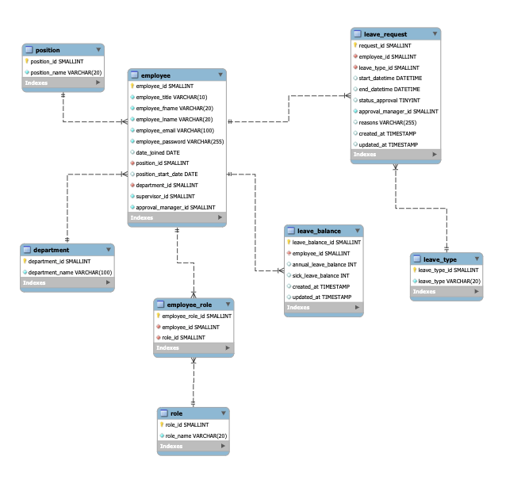

### Proposed Time Allocation

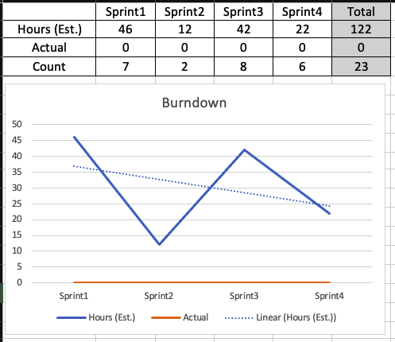

### Sprint 1 Planning

|  |  |  |
| --- | --- | --- |
| **To do** | **Assign to** | **Estimate Hours** |
| **User stories** | **Miao/mia/sherlyn** | Miao-2  Mia-2  Sherlyn-2 |
| **ERD - Database Design - Database creation** | **hido/belinda/miao** | Belinda-7.5  Hido-1  Miao-1 |
| **User Flow Diagram - research other systems** | **sherlyn/belinda** | Sherlyn-4  Belinda-2 |
| **planning - calculations for the leave ...** | **mia/miao** | Mia-4  Miao-4 |
| **research all systems** | **hido/mia/sherlyn** | Sherlyn-8  Mia-3  Hido-6 |
| **prototype - using figma or balsamiq** | **miao/mia** | Miao-8  Mia-6 |